Bahria University,

Karachi Campus



COURSE: WEB ENGINEERING

TERM: FALL 2023, CLASS: BSE- 5 (A)

PROJECT NAME: VITALITY WEB APPLICATION

Engr.Adnan/Engr. Ayesha

Signed Remarks: Score:

HEADINGS:

1. TABLE OF CONTENT

|  |  |
| --- | --- |
| Heading | Page no. |
| INTRODUCTION & PROBLEM | 2 |
| TECHNOLOGY | 3 |
| FUNCTIONALITIES | 4 |
| MODULE DISTRIBUTION | 5 |
| CODE | 6 |
| INTERFACES | 23 |
| FIGMA SCREENSHOTS | 35 |
| GITHUB SCREENSHOTS | 44 |
| CONCLUSION | 45 |

1. INTRODUCTION & PROBLEM

For both newcomers and seasoned enthusiasts, pursuing fitness goals can be a difficult journey in this age of information overload. The Vitality Fitness Website is a shining example of wellness that is ready to transform the way people approach their fitness goals. This digital platform is a complete solution for beginners as well as professionals in the fitness industry, as it is dedicated to assisting users in creating a personalized and knowledgeable fitness experience.

There is an overflow of fitness information on the internet that can be confusing and overwhelming for people who want to start a wellness journey. For fitness enthusiasts, sorting through the multitude of diet plans, exercise regimens, and health advice available online can be confusing and frustrating, which may hinder their progress. One major barrier to effectively reaching fitness goals is the absence of a centralized, user-centric platform that integrates progress tracking, expert insights, and personalized guidance.

The Vitality Fitness Website stands out as a revolutionary response to this problem, seeking to simplify and accelerate the fitness journey. Through the utilization of technology, personalization, and expert knowledge, this platform aims to offer users a guided path that makes their pursuit of fitness enjoyable as well as effective. With customized exercise regimens, dietary advice, progress monitoring, and an AI chatbot, the Vitality Fitness Website becomes a digital assistant that provides a wellness-focused approach that goes beyond traditional fitness platforms.

1. TECHNOLOGY

Utilizing a wide range of technologies, the Vitality Fitness Website offers a smooth and feature-rich user experience. The platform's ability to offer individualized fitness solutions, professional advice, and an interactive user interface is made possible by the combination of cutting-edge tools. The following are the main technologies used in the creation of the website:

* Node.js:

Because the server-side component is based on Node.js, server operations can be handled more effectively, and scalability is guaranteed for an expanding user base.

* React:

The web application's front end is created with the help of React, a powerful JavaScript package. The user experience is improved overall by using React to create dynamic and responsive user interfaces.

* MongoDB:

MongoDB is a NoSQL database that is used to store and manage user data, diet plans, exercise schedules, and other important application components. The dynamic nature of fitness data is in line with its scalability and flexibility.

* Natural Language Processing (NLP):

The AI chatbot is trained using natural language processing (NLP) to enable it to comprehend user inquiries and reply in a conversational and organic way. By giving users access to current and relevant fitness-related information, this technology enhances user interaction.

* Visual Studio Code:

The web application is created using Visual Studio Code, an integrated development environment (IDE). Because of its adaptable features and extensions, the development process runs more smoothly, which helps to create a solid and user-friendly platform.

1. FUNCTIONALITIES

* Tailored Exercise Programs:

Customized exercise programs depending on data supplied by the user, including weight, fitness objectives, and preferences. Plans include exercises to build muscle, lose weight, and improve general fitness.

* Dietary Guidelines:

Tailored diet programs in line with users' fitness goals and weight classes. The platform promotes a holistic approach to health by suggesting meals that go well with exercise regimens.

* Calorie Estimator:

Users can track their daily caloric intake with the aid of an integrated calorie calculator, which offers insights into nutrition and supports the maintenance of a balanced diet.

* Recipes Section:

Recipes that are categorized and offer a range of options, such as low-fat, high-protein, and other diet-specific recipes. To help consumers make educated dietary decisions, nutritional information is included with every recipe.

* Progress Tracking:

The application provides visual displays of accomplishments and advancements while tracking users' progress over time. This feature encourages motivation and offers a brief overview of fitness achievements.

* Reward System:

Users' achievements, like finishing a certain number of workouts, are recognized by a motivational reward system. Rewards work as incentives, promoting steady commitment to fitness objectives.

* Chatbot powered by AI:

An AI-driven chatbot that can respond to inquiries from users about fitness. Instant access to professional advice is made possible by the chatbot, which promotes an engaging and dynamic user experience.

* Health Articles:

A carefully chosen blog area with health-related articles written by reputable fitness professionals. To keep informed and inspired, users can obtain insightful information, advice, and industry trends related to the fitness sector.

1. MODULE DISTRIBUTION

* Haseebullah
  1. Frontend
  2. Calorie calculator
  3. Recipes
* Kashan Riaz

1. Login/Signup
2. Workout

* Eima Nasir

1. Chatbot
2. Articles
3. Database
4. CODE

Chatbot index.html:

<!DOCTYPE html>

<html lang="en">

<head>

<meta charset="UTF-8">

<meta name="viewport" content="width=device-width, initial-scale=1.0">

<title>Trained Chatbot</title>

<!-- Bootstrap CSS CDN -->

<link rel="stylesheet" href="https://maxcdn.bootstrapcdn.com/bootstrap/4.5.2/css/bootstrap.min.css">

<style>

body {

background-color: #f8f9fa;

padding: 20px;

font-family: 'Segoe UI', Tahoma, Geneva, Verdana, sans-serif;

}

#chat-container {

max-width: 600px;

margin: 0 auto;

border-radius: 10px;

overflow: hidden;

box-shadow: 0 0 10px rgba(0, 0, 0, 0.1);

}

#chat-box {

height: 300px;

overflow-y: scroll;

border-top-left-radius: 10px;

border-top-right-radius: 10px;

border: 2px solid #007bff;

border-bottom: 0;

padding: 15px;

margin-bottom: 20px;

background-color: #ffffff;

box-shadow: 0 2px 5px rgba(0, 0, 0, 0.1);

}

.message {

margin-bottom: 15px;

padding: 10px;

border-radius: 10px;

font-size: 16px;

}

.user-message {

background-color: #007bff;

color: #ffffff;

}

.bot-message {

background-color: #28a745;

color: #ffffff;

}

#user-input {

display: flex;

align-items: center;

border-top: 2px solid #007bff;

padding: 10px;

background-color: #ffffff;

border-bottom-left-radius: 10px;

border-bottom-right-radius: 10px;

}

#user-message {

flex: 1;

border-top-right-radius: 0;

border-bottom-right-radius: 0;

}

.input-group-append button {

border-top-left-radius: 0;

border-bottom-left-radius: 0;

border-top-right-radius: 10px;

border-bottom-right-radius: 10px;

}

#instant-answer-panel {

margin-top: 20px;

}

.instant-answer-btn {

margin-right: 10px;

margin-bottom: 10px;

border-radius: 20px;

transition: background-color 0.3s ease;

}

.instant-answer-btn:hover {

background-color: #007bff;

color: #ffffff;

}

</style>

</head>

<body>

<div id="chat-container" class="container">

<div id="chat-box" class="bg-light">

<!-- Welcome message -->

<div class="message bot-message">

<strong>Bot:</strong> Welcome! Type a message to start the conversation.

</div>

</div>

<div id="user-input" class="input-group">

<input type="text" id="user-message" class="form-control" placeholder="Type your message...">

<div class="input-group-append">

<button class="btn btn-primary" onclick="sendMessage()">Send</button>

</div>

</div>

</div>

<!-- Instant Answer Panel -->

<div id="instant-answer-panel" class="container">

<h5>Common Questions:</h5>

<button class="btn btn-secondary instant-answer-btn" onclick="sendInstantAnswer('How can I gain muscle?')">Muscle Gain</button>

<button class="btn btn-secondary instant-answer-btn" onclick="sendInstantAnswer('What diet should I follow for home workouts?')">Diet</button>

<button class="btn btn-secondary instant-answer-btn" onclick="sendInstantAnswer('How often should I do home workouts?')">Workout Frequency</button>

<button class="btn btn-secondary instant-answer-btn" onclick="sendInstantAnswer('Should I take supplements for home workouts?')">Supplements</button>

</div>

<!-- Bootstrap JS and Popper.js CDN -->

<script src="https://code.jquery.com/jquery-3.5.1.slim.min.js"></script>

<script src="https://cdn.jsdelivr.net/npm/@popperjs/core@2.5.1/dist/umd/popper.min.js"></script>

<script src="https://cdn.jsdelivr.net/npm/bootstrap@4.5.2/dist/js/bootstrap.min.js"></script>

<!-- Chatbot Logic -->

<!-- Chatbot Logic -->

<script src="/socket.io/socket.io.js"></script>

<script>

document.getElementById('user-message').addEventListener('keypress', function (e) {

if (e.key === 'Enter') {

sendMessage();

}

});

function sendMessage() {

const userMessage = document.getElementById('user-message').value;

appendMessage('You', userMessage, 'user-message');

document.getElementById('user-message').value = '';

// Send the user message to the server and get the response

fetch(`/bot?message=${encodeURIComponent(userMessage)}`)

.then(response => response.text())

.then(botResponse => appendMessage('Bot', botResponse, 'bot-message'))

.catch(error => console.error('Error sending message:', error));

}

function sendInstantAnswer(question) {

// Display the question being sent

appendMessage('You', question, 'user-message');

// Automatically send the question to the server and get the response

fetch(`/bot?message=${encodeURIComponent(question)}`)

.then(response => response.text())

.then(botResponse => appendMessage('Bot', botResponse, 'bot-message'))

.catch(error => console.error('Error sending message:', error));

}

function appendMessage(sender, message, messageType) {

const chatBox = document.getElementById('chat-box');

const messageDiv = document.createElement('div');

messageDiv.innerHTML = `<strong>${sender}:</strong> ${message}`;

messageDiv.classList.add('message', messageType);

chatBox.appendChild(messageDiv);

// Scroll to the bottom of the chat box

chatBox.scrollTop = chatBox.scrollHeight;

}

</script>

</body>

</html>

Chatbot index.js:

const { NlpManager } = require('node-nlp');

const express = require('express');

const path = require('path');

const app = express();

const manager = new NlpManager({ languages: ['en'] });

// Add documents

manager.addDocument('en', 'hello', 'greeting');

manager.addDocument('en', 'hi', 'greeting');

manager.addDocument('en', 'hey', 'greeting');

manager.addDocument('en', 'hey you', 'greeting');

manager.addDocument('en', 'good morning', 'greeting');

manager.addDocument('en', 'good afternoon', 'greeting');

manager.addDocument('en', 'good day', 'greeting');

manager.addDocument('en', 'yo', 'greeting');

manager.addDocument('en', 'i must go', 'greetings.bye');

manager.addDocument('en', 'bye for now', 'greetings.bye');

manager.addDocument('en', 'okay see you later', 'greetings.bye');

manager.addDocument('en', 'bye bye take care', 'greetings.bye');

manager.addDocument('en', 'good bye for now', 'greetings.bye');

// Home workout queries

manager.addDocument('en', 'What home workout plans do you offer?', 'homeWorkout.plans');

manager.addDocument('en', 'Can you recommend a home workout for weight loss?', 'homeWorkout.weightLoss');

manager.addDocument('en', 'What is the best home workout for muscle gain?', 'homeWorkout.muscleGain');

manager.addDocument('en', 'Tell me about your home workout routines', 'homeWorkout.routines');

manager.addDocument('en', 'Do you provide guided home workout videos?', 'homeWorkout.videos');

manager.addDocument('en', 'What is the duration of your home workout programs?', 'homeWorkout.duration');

manager.addDocument('en', 'How often should I do home workouts?', 'homeWorkout.frequency');

manager.addDocument('en', 'Can you suggest a beginner-friendly home workout?', 'homeWorkout.beginner');

// Diet-related questions for home workouts

manager.addDocument('en', 'What diet should I follow for home workouts?', 'homeDiet.recommendation');

manager.addDocument('en', 'Do you provide nutritional guidance for home workouts?', 'homeDiet.nutritionalGuidance');

manager.addDocument('en', 'Should I take supplements for home workouts?', 'homeDiet.supplements');

manager.addDocument('en', 'What is the best meal before a home workout?', 'homeDiet.preWorkoutMeal');

manager.addDocument('en', 'How many calories should I consume for home workouts?', 'homeDiet.calories');

manager.addDocument('en', 'How to stay motivated during home workouts?', 'homeWorkout.motivation');

manager.addDocument('en', 'Tell me about your home workout challenges', 'homeWorkout.challenges');

manager.addDocument('en', 'What equipment do I need for home workouts?', 'homeWorkout.equipment');

manager.addDocument('en', 'How to cool down after a home workout?', 'homeWorkout.coolDown');

manager.addDocument('en', 'Can I do home workouts if I have limited space?', 'homeWorkout.limitedSpace');

manager.addDocument('en', 'What is the importance of stretching in home workouts?', 'homeWorkout.stretching');

// Additional Diet-related questions for home workouts

manager.addDocument('en', 'Is intermittent fasting suitable for home workouts?', 'homeDiet.intermittentFasting');

manager.addDocument('en', 'How to manage diet for weight loss during home workouts?', 'homeDiet.weightLossManagement');

manager.addDocument('en', 'What snacks are good for post-home workout recovery?', 'homeDiet.postWorkoutSnacks');

manager.addDocument('en', 'Are there vegetarian/vegan diet options for home workouts?', 'homeDiet.vegetarianVeganOptions');

manager.addDocument('en', 'How to handle cravings during a home workout program?', 'homeDiet.cravingsManagement');

manager.addDocument('en', 'What are some high protein vegetarian options?', 'diet.high_protein_vegetarian');

manager.addDocument('en', 'Tell me about vegetarian sources of protein', 'diet.high_protein_vegetarian');

manager.addDocument('en', 'What are good sources of high protein for vegetarians?', 'diet.high_protein_vegetarian');

manager.addDocument('en', 'Give me examples of high carb foods', 'diet.high_carb');

manager.addDocument('en', 'What are good sources of carbohydrates?', 'diet.high_carb');

manager.addDocument('en', 'Tell me about foods that are rich in carbohydrates', 'diet.high_carb');

manager.addDocument('en', 'What are some vegetarian options for a high carb diet?', 'diet.high_carb_vegetarian');

manager.addDocument('en', 'Give me examples of high carb vegetarian foods', 'diet.high_carb_vegetarian');

manager.addDocument('en', 'Tell me about vegetarian sources of carbohydrates', 'diet.high_carb_vegetarian');

// Add documents for diet guidance

manager.addDocument('en', 'Guide me on diets', 'diet.guide');

manager.addDocument('en', 'Give me a diet plan', 'diet.guide');

manager.addDocument('en', 'Help with meal planning', 'diet.guide');

manager.addDocument('en', 'Provide a personalized diet recommendation', 'diet.guide');

manager.addDocument('en', 'Suggest a diet for me', 'diet.guide');

// Add answers

manager.addAnswer('en', 'greeting', 'Hey!');

manager.addAnswer('en', 'greeting', 'Hey!');

manager.addAnswer('en', 'greeting', 'Hello there');

manager.addAnswer('en', 'greeting', 'Hi');

manager.addAnswer('en', 'greeting', 'Yo whatsup');

manager.addAnswer('en', 'greetings.bye', 'Till next time');

manager.addAnswer('en', 'greetings.bye', 'See you soon!');

// Home workout responses

manager.addAnswer('en', 'homeWorkout.plans', 'We offer various home workout plans designed for different fitness goals.');

manager.addAnswer('en', 'homeWorkout.weightLoss', 'For weight loss, try our high-intensity interval training (HIIT) home workouts.');

manager.addAnswer('en', 'homeWorkout.muscleGain', 'To gain muscle at home, focus on bodyweight exercises and resistance training.');

manager.addAnswer('en', 'homeWorkout.routines', 'Our home workout routines cover a range of exercises targeting different muscle groups.');

manager.addAnswer('en', 'homeWorkout.videos', 'Yes, we provide guided home workout videos to help you with your exercises.');

manager.addAnswer('en', 'homeWorkout.duration', 'The duration of our home workout programs varies. Check our website for specific details.');

manager.addAnswer('en', 'homeWorkout.frequency', 'We recommend doing home workouts 3-5 times a week, depending on your fitness level.');

manager.addAnswer('en', 'homeWorkout.beginner', 'For beginners, start with short and simple home workouts. Focus on proper form and consistency.');

// Diet-related responses for home workouts

manager.addAnswer('en', 'homeDiet.recommendation', 'Follow a balanced diet with adequate protein, carbs, and healthy fats for your home workouts.');

manager.addAnswer('en', 'homeDiet.nutritionalGuidance', 'Our nutritional guidance includes tips on healthy eating habits to complement your home workouts.');

manager.addAnswer('en', 'homeDiet.supplements', 'While not required, supplements can be considered. Consult with a healthcare professional for personalized advice.');

manager.addAnswer('en', 'homeDiet.preWorkoutMeal', 'Have a light meal with carbs and protein about 1-2 hours before your home workout for sustained energy.');

manager.addAnswer('en', 'homeDiet.calories', 'Caloric needs vary. Consider your fitness goals and consult with a nutritionist for personalized caloric intake.');

// Additional Home workout responses

manager.addAnswer('en', 'homeWorkout.motivation', 'Staying motivated is essential. Set realistic goals, track progress, and vary your home workouts to keep things interesting.');

manager.addAnswer('en', 'homeWorkout.challenges', 'Participate in our home workout challenges to add excitement to your fitness routine and win rewards.');

manager.addAnswer('en', 'homeWorkout.equipment', 'Most of our home workouts require minimal equipment such as resistance bands or dumbbells. You can also do bodyweight exercises.');

manager.addAnswer('en', 'homeWorkout.coolDown', 'After a home workout, perform gentle stretches to cool down and improve flexibility. Hydrate and rest as needed.');

manager.addAnswer('en', 'homeWorkout.limitedSpace', 'Yes, you can still do effective home workouts in limited space. Focus on bodyweight exercises and use compact equipment.');

manager.addAnswer('en', 'homeWorkout.stretching', 'Stretching is crucial for flexibility and preventing injuries. Include dynamic stretches before and static stretches after your home workouts.');

// Additional Diet-related responses for home workouts

manager.addAnswer('en', 'homeDiet.intermittentFasting', 'Intermittent fasting can be compatible with home workouts. Consult with a nutritionist to adapt it to your fitness goals.');

manager.addAnswer('en', 'homeDiet.weightLossManagement', 'For weight loss during home workouts, focus on a balanced diet, portion control, and staying hydrated.');

manager.addAnswer('en', 'homeDiet.postWorkoutSnacks', 'Opt for snacks with a balance of protein and carbs for post-home workout recovery. Examples include yogurt with fruit or a protein smoothie.');

manager.addAnswer('en', 'homeDiet.vegetarianVeganOptions', 'We offer vegetarian and vegan diet options to support your home workouts. Explore plant-based protein sources and balanced meals.');

manager.addAnswer('en', 'homeDiet.cravingsManagement', 'Manage cravings during home workouts by choosing healthier alternatives, staying hydrated, and addressing emotional eating with mindfulness.');

manager.addAnswer('en', 'diet.high_protein_vegetarian', 'Some high protein vegetarian options include tofu, lentils, chickpeas, quinoa, and Greek yogurt.');

manager.addAnswer('en', 'diet.high_protein_vegetarian', 'Vegetarian sources of protein include beans, legumes, nuts, seeds, and plant-based protein powders.');

manager.addAnswer('en', 'diet.high_carb', 'Good sources of carbohydrates include whole grains, fruits, vegetables, and legumes.');

manager.addAnswer('en', 'diet.high_carb', 'Carbohydrate-rich foods include brown rice, sweet potatoes, oats, and bananas.');

manager.addAnswer('en', 'diet.high_carb_vegetarian', 'Vegetarian options for a high carb diet include pasta, rice, potatoes, and whole grain bread.');

manager.addAnswer('en', 'diet.high_carb_vegetarian', 'You can get carbohydrates from vegetarian sources like quinoa, beans, lentils, and whole wheat products.');

// Add answers for diet guidance

manager.addAnswer('en', 'diet.guide', 'Sure! I can help you with that. To provide personalized diet advice, could you please share some information about your dietary preferences, goals, and any dietary restrictions you may have?');

manager.addAnswer('en', 'diet.guide', 'Absolutely! I can assist you with a diet plan. Before we proceed, could you let me know your dietary preferences, goals, and any specific requirements you have?');

manager.addAnswer('en', 'diet.guide', 'Certainly! Let me guide you on creating a personalized diet plan. To get started, could you share some details about your dietary preferences, goals, and any restrictions you may have?');

// Train model with use of promise

(async () => {

try {

await manager.train();

manager.save();

} catch (error) {

console.error('Error during training:', error);

}

})();

// Serve the static files in the 'public' folder

app.use(express.static(path.join(__dirname, 'public')));

app.get('/bot', async (req, res) => {

try {

const response = await manager.process('en', req.query.message);

res.send(response.answer || 'Please rephrase');

} catch (error) {

console.error('Error processing message:', error);

res.status(500).send('Internal Server Error');

}

});

app.listen(3000, () => {

console.log('Server is running on port 3000');

});

Using auth0 for server tokens and login/signup:

import React from "react";

import { createRoot } from "react-dom/client";

import App from "./App";

import reportWebVitals from "./reportWebVitals";

import { BrowserRouter } from "react-router-dom";

import "./global.css";

import { Auth0Provider } from '@auth0/auth0-react';

const container = document.getElementById("root");

const root = createRoot(container);

root.render(

<BrowserRouter>

<Auth0Provider

domain="dev-sdc44npgyw57szbn.us.auth0.com"

clientId="7ryvmAhO0GCZilOJF4SffGiA5x4PJhZ7"

authorizationParams={{

redirect_uri: window.location.origin

}}

>

<App />

</Auth0Provider>

</BrowserRouter>

);

// If you want to start measuring performance in your app, pass a function

// to log results (for example: reportWebVitals(console.log))

// or send to an analytics endpoint. Learn more: https://bit.ly/CRA-vitals

reportWebVitals();

import React, { useState, useCallback, useEffect } from "react";

import { useNavigate } from "react-router-dom";

import styles from "./Login.module.css";

import { useAuth0 } from "@auth0/auth0-react";

const Login = () => {

const { loginWithRedirect, isAuthenticated, getAccessTokenSilently } = useAuth0();

const [emailFieldValue, setEmailFieldValue] = useState("");

const [passwordFieldValue, setPasswordFieldValue] = useState("");

const navigate = useNavigate();

const loginsuccess = useCallback(() => {

navigate("/homepage");

}, [navigate]);

const loginfailed = useCallback(() => {

navigate("/LandingPage");

}, [navigate]);

useEffect(() => {

const handleRedirectCallback = async () => {

const isAuthenticated = await getAccessTokenSilently().then(() => true).catch(() => false);

if (isAuthenticated) {

loginsuccess();

} else {

loginfailed();

}

};

handleRedirectCallback();

}, [getAccessTokenSilently, loginsuccess, loginfailed]);

const handleLogin = () => {

loginWithRedirect();

};

return (

<div className={styles.login}>

<section className={styles.loginsubframe}>

<img

className={styles.loginpictureIcon}

alt=""

src="/loginpicture@2x.png"

/>

<p className={styles.email}>Email:</p>

<p className={styles.password}>Password:</p>

<input

className={styles.emailfield}

type="text"

value={emailFieldValue}

onChange={(event) => setEmailFieldValue(event.target.value)}

/>

<input

className={styles.passwordfield}

type="text"

value={passwordFieldValue}

onChange={(event) => setPasswordFieldValue(event.target.value)}

/>

<h1 className={styles.welcomeBackChampion}>Welcome back, champion!</h1>

<h1 className={styles.login1}>LOGIN</h1>

<button className={styles.loginbutton} onClick={handleLogin}>

<button

className={styles.loginbutton1}

onClick={handleLogin}

/>

<div className={styles.login2}>Login</div>

</button>

</section>

<img className={styles.bluelogoIcon} alt="" src="/blue-logo-3@2x.png" />

</div>

);

};

export default Login;

Landing page js code:

import { useState, useCallback } from "react";

import { useNavigate } from "react-router-dom";

import styles from "./LandingPage.module.css";

const LandingPage = () => {

const [newsletterValue, setNewsletterValue] = useState("");

const navigate = useNavigate();

const onLoginButtonContainerClick = useCallback(() => {

navigate("/login");

}, [navigate]);

const onSignupButtonContainerClick = useCallback(() => {

navigate("/signup");

}, [navigate]);

const onFacebookIconClick = useCallback(() => {

window.open("https://www.facebook.com/");

}, []);

const onXIconClick = useCallback(() => {

window.open("https://twitter.com/");

}, []);

const onInstagramIconClick = useCallback(() => {

window.open("https://www.instagram.com/");

}, []);

const onWhatsappIconClick = useCallback(() => {

window.open("https://www.whatsapp.com/");

}, []);

return (

<div className={styles.landingpage}>

<img

className={styles.landingpagelogoIcon}

alt="logo"

src="/blue-logo-1@2x.png"

/>

<div className={styles.loginbutton} onClick={onLoginButtonContainerClick}>

<label className={styles.login}>Login</label>

</div>

<img

className={styles.desertyoga1Icon}

alt=""

src="/desertyoga-1@2x.png"

/>

<h1 className={styles.revolutionizeYourFitnessContainer}>

<span className={styles.revolutionizeYourFitnessContainer1}>

<p className={styles.revolutionizeYourFitnessJou}>

<span className={styles.revolutionizeYou}>Revolutionize you</span>

<span>r fitness journey</span>

</p>

<p className={styles.withOurCuttingEdgeWebApp}>

<span className={styles.revolutionizeYou}>with our cutting-e</span>

<span className={styles.dgeWebApp}>dge web app,</span>

<span>{` `}</span>

</p>

<p className={styles.yourAllInOneSolutionFor}>

<span>your all-in-one sol</span>

<span className={styles.dgeWebApp}>{`ution for `}</span>

</p>

<p className={styles.yourAllInOneSolutionFor}>

<span className={styles.revolutionizeYou}>workouts, diets, a</span>

<span>{`nd everything else `}</span>

</p>

<p className={styles.yourAllInOneSolutionFor}>

<span className={styles.revolutionizeYou}>related to achievi</span>

<span>ng your peak health</span>

<span className={styles.revolutionizeYou}>.</span>

</p>

</span>

</h1>

<h1 className={styles.keepUpWithContainer}>

<span className={styles.revolutionizeYourFitnessContainer1}>

<span>{`KEEP UP WITH THE LATEST, FOR ALL THINGS `}</span>

<span className={styles.vitality}>VITALITY</span>

<span>. DROP YOUR EMAIL BELOW, AND LET’S STAY CONNECTED.</span>

</span>

</h1>

<img className={styles.linesIcon} alt="" src="/lines@2x.png" />

<img

className={styles.chiggaChilling1}

alt=""

src="/chigga-chilling-1@2x.png"

/>

<div

className={styles.signupbutton}

onClick={onSignupButtonContainerClick}

>

<label className={styles.signUp}>Sign up</label>

</div>

<h1 className={styles.welcomeToAContainer}>

<span className={styles.revolutionizeYourFitnessContainer1}>

<p className={styles.yourAllInOneSolutionFor}>

<span className={styles.we}>WE</span>

<span>LCOME TO A</span>

</p>

<p className={styles.yourAllInOneSolutionFor}>

<span className={styles.we}>STRONG A</span>

<span>ND HEALTHY</span>

</p>

<p className={styles.youWithVitality}>

<span className={styles.we}>{`YOU `}</span>

<span className={styles.w}>W</span>

<span className={styles.revolutionizeYou}>{`ITH `}</span>

<span>{`VITALITY `}</span>

</p>

</span>

</h1>

<div className={styles.footer}>

<a

className={styles.facebookicon}

href="https://www.facebook.com/"

target="_blank"

onClick={onFacebookIconClick}

>

<img className={styles.socialIcons} alt="" src="/social-icons.svg" />

</a>

<a

className={styles.xicon}

href="https://twitter.com"

target="_blank"

onClick={onXIconClick}

>

<img className={styles.vectorIcon} alt="" src="/vector.svg" />

</a>

<a

className={styles.instagramicon}

href="https://www.instagram.com/"

target="_blank"

onClick={onInstagramIconClick}

>

<img className={styles.socialIcons} alt="" src="/vector1.svg" />

<img className={styles.vectorIcon2} alt="" src="/vector2.svg" />

<img className={styles.vectorIcon3} alt="" src="/vector3.svg" />

</a>

<a

className={styles.whatsappicon}

href="https://www.whatsapp.com/"

target="_blank"

onClick={onWhatsappIconClick}

>

<img className={styles.vectorIcon4} alt="" src="/vector4.svg" />

</a>

<p className={styles.vitalityco2023}>Vitality.coⒸ2023</p>

</div>

<input

className={styles.newsletter}

placeholder="Enter your Email"

type="text"

value={newsletterValue}

onChange={(event) => setNewsletterValue(event.target.value)}

/>

</div>

);

};

export default LandingPage;

Landing page css code:

.landingpagelogoIcon {

position: absolute;

top: 88px;

left: calc(50% - 154px);

width: 307px;

height: 46px;

object-fit: cover;

}

.login,

.loginbutton {

position: absolute;

cursor: pointer;

}

.login {

top: 12px;

left: -17px;

letter-spacing: 1px;

line-height: 16px;

display: flex;

align-items: center;

justify-content: center;

width: 117px;

}

.loginbutton {

top: 544px;

left: calc(50% + 231px);

border-radius: var(--br-smi);

background-color: var(--color-midnightblue-100);

border: 2px solid var(--color-black);

box-sizing: border-box;

width: 83px;

height: 40px;

overflow: hidden;

font-size: var(--font-size-base);

}

.desertyoga1Icon {

position: absolute;

top: 763px;

left: calc(50% - 26px);

width: 468px;

height: 699px;

object-fit: cover;

}

.revolutionizeYou {

color: var(--color-black);

}

.revolutionizeYourFitnessJou {

margin: 0;

color: var(--color-indianred);

}

.dgeWebApp {

color: var(--color-indianred);

}

.withOurCuttingEdgeWebApp {

margin: 0;

color: var(--color-black);

}

.yourAllInOneSolutionFor {

margin: 0;

}

.revolutionizeYourFitnessContainer1 {

width: 100%;

}

.revolutionizeYourFitnessContainer {

margin: 0;

position: absolute;

top: 916px;

left: calc(50% - 405px);

font-size: inherit;

line-height: 75px;

font-weight: 400;

font-family: var(--font-helvetica-light);

text-align: left;

display: flex;

align-items: center;

width: 809px;

height: 360px;

color: var(--color-lightslategray);

}

.vitality {

color: #6f4aa1;

}

.keepUpWithContainer {

margin: 0;

position: absolute;

top: 1630.1px;

left: calc(50% - 771px);

font-size: inherit;

line-height: 75px;

font-weight: 400;

font-family: var(--font-garamond);

display: flex;

align-items: center;

width: 1542px;

height: 296.2px;

}

.chiggaChilling1,

.linesIcon {

position: absolute;

top: 1623px;

left: calc(50% - 711px);

width: 1422px;

height: 255.9px;

object-fit: cover;

}

.chiggaChilling1 {

top: 313px;

left: calc(50% - 493px);

width: 546px;

height: 436px;

}

.signUp,

.signupbutton {

position: absolute;

cursor: pointer;

}

.signUp {

top: 12px;

left: -4px;

letter-spacing: 1px;

line-height: 16px;

display: flex;

align-items: center;

justify-content: center;

width: 91px;

height: 16px;

}

.signupbutton {

top: 544px;

left: calc(50% + 102px);

border-radius: var(--br-smi);

background-color: var(--color-midnightblue-100);

border: 2px solid var(--color-black);

box-sizing: border-box;

width: 83px;

height: 40px;

overflow: hidden;

font-size: 14px;

}

.we {

color: var(--color-white);

}

.w {

color: var(--color-gray-100);

}

.youWithVitality {

margin: 0;

color: #27005d;

}

.welcomeToAContainer {

margin: 0;

position: absolute;

top: 327px;

left: calc(50% - 209px);

font-size: inherit;

line-height: 75px;

font-weight: 400;

font-family: var(--font-helvetica-light);

text-align: right;

display: flex;

align-items: center;

width: 553px;

height: 192px;

}

.socialIcons {

position: absolute;

height: 100%;

width: 100%;

top: 0;

right: 0;

bottom: 0;

left: 0;

max-width: 100%;

overflow: hidden;

max-height: 100%;

}

.facebookicon {

text-decoration: none;

position: absolute;

top: 73px;

left: calc(50% - 72.5px);

width: 22px;

height: 22px;

cursor: pointer;

}

.vectorIcon,

.xicon {

position: absolute;

overflow: hidden;

}

.vectorIcon {

height: 82.73%;

width: 91.82%;

top: 7.73%;

right: 4.09%;

bottom: 9.55%;

left: 4.09%;

max-width: 100%;

max-height: 100%;

}

.xicon {

text-decoration: none;

top: 73px;

left: calc(50% - 31.5px);

width: 22px;

height: 22px;

cursor: pointer;

}

.vectorIcon2,

.vectorIcon3 {

max-width: 100%;

max-height: 100%;

}

.vectorIcon2 {

position: absolute;

height: 51.36%;

width: 51.36%;

top: 24.09%;

right: 24.55%;

bottom: 24.55%;

left: 24.09%;

overflow: hidden;

}

.vectorIcon3 {

height: 11.82%;

width: 11.82%;

top: 17.27%;

right: 17.27%;

bottom: 70.91%;

left: 70.91%;

}

.instagramicon,

.vectorIcon3,

.vectorIcon4 {

position: absolute;

overflow: hidden;

}

.instagramicon {

text-decoration: none;

top: 73px;

left: calc(50% + 9.5px);

width: 22px;

height: 22px;

cursor: pointer;

}

.vectorIcon4 {

height: 100%;

width: 99.55%;

top: 0;

right: 0.45%;

bottom: 0;

left: 0;

max-width: 100%;

max-height: 100%;

}

.whatsappicon {

text-decoration: none;

position: absolute;

top: 73px;

left: calc(50% + 50.5px);

width: 22px;

height: 22px;

cursor: pointer;

}

.vitalityco2023 {

margin: 0;

position: absolute;

top: 42.5px;

left: calc(50% - 90.5px);

letter-spacing: 3px;

line-height: 27px;

display: flex;

align-items: center;

justify-content: center;

width: 181px;

height: 19px;

}

.footer {

position: absolute;

bottom: -40px;

left: calc(50% - 295px);

border-radius: var(--br-11xl);

background-color: var(--color-gray-200);

border: 3px solid var(--color-black);

box-sizing: border-box;

width: 539px;

height: 145px;

overflow: hidden;

font-size: var(--font-size-base);

font-family: var(--font-helvetica);

}

.landingpage,

.newsletter {

font-family: var(--font-futura-bk-bt);

}

.newsletter {

border: 3px solid var(--color-black);

outline: 0;

font-size: var(--font-size-xl);

background-color: var(--color-midnightblue-100);

position: absolute;

top: 1951px;

left: calc(50% - 389px);

border-radius: 45px;

box-shadow: 0 4px 4px rgba(0, 0, 0, 0.25);

box-sizing: border-box;

width: 779px;

height: 78px;

padding: 28px 308px 27px;

color: rgba(0, 0, 0, 0.53);

}

.landingpage {

position: relative;

background-color: var(--color-white);

width: 100%;

height: 2428px;

overflow: hidden;

text-align: center;

font-size: var(--font-size-29xl);

color: var(--color-black);

}

1. INTERFACES

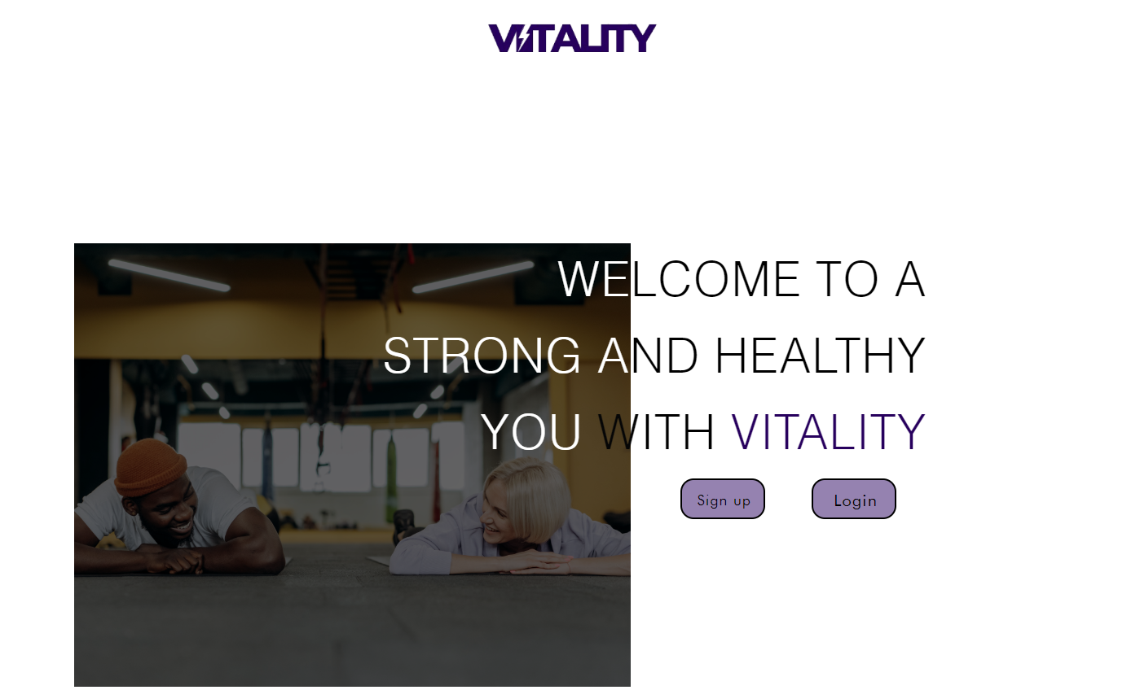

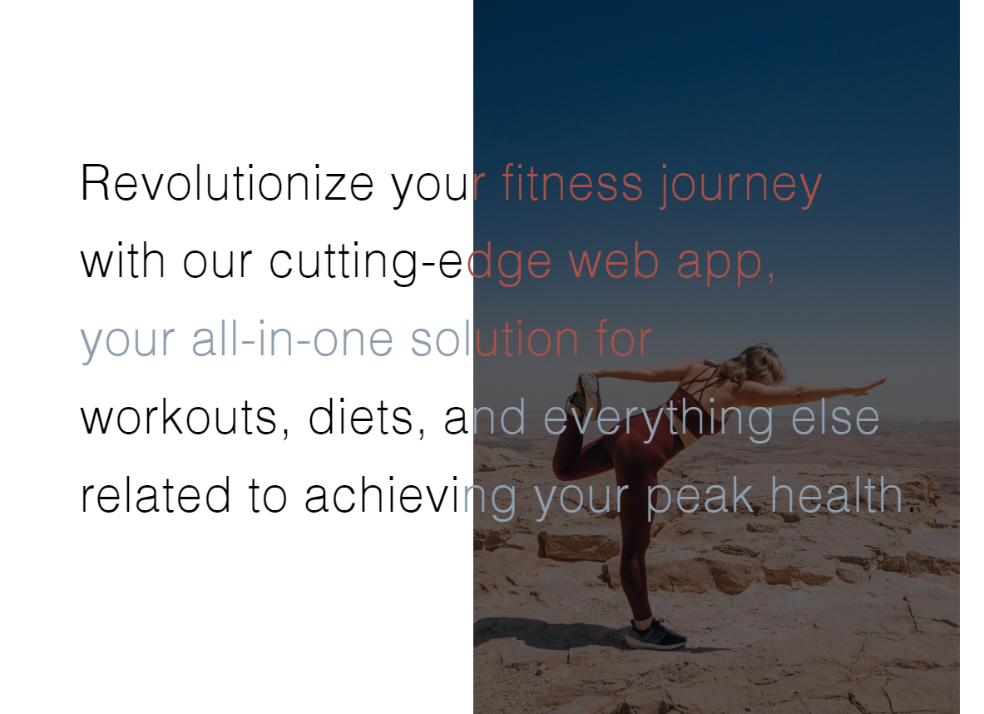

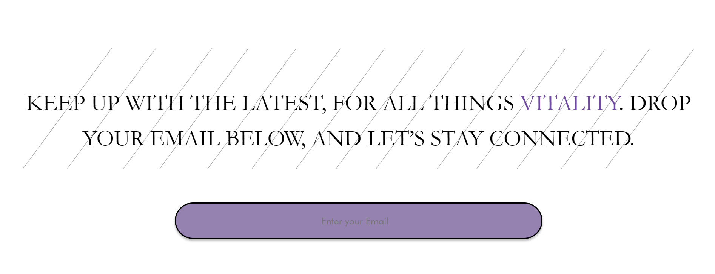

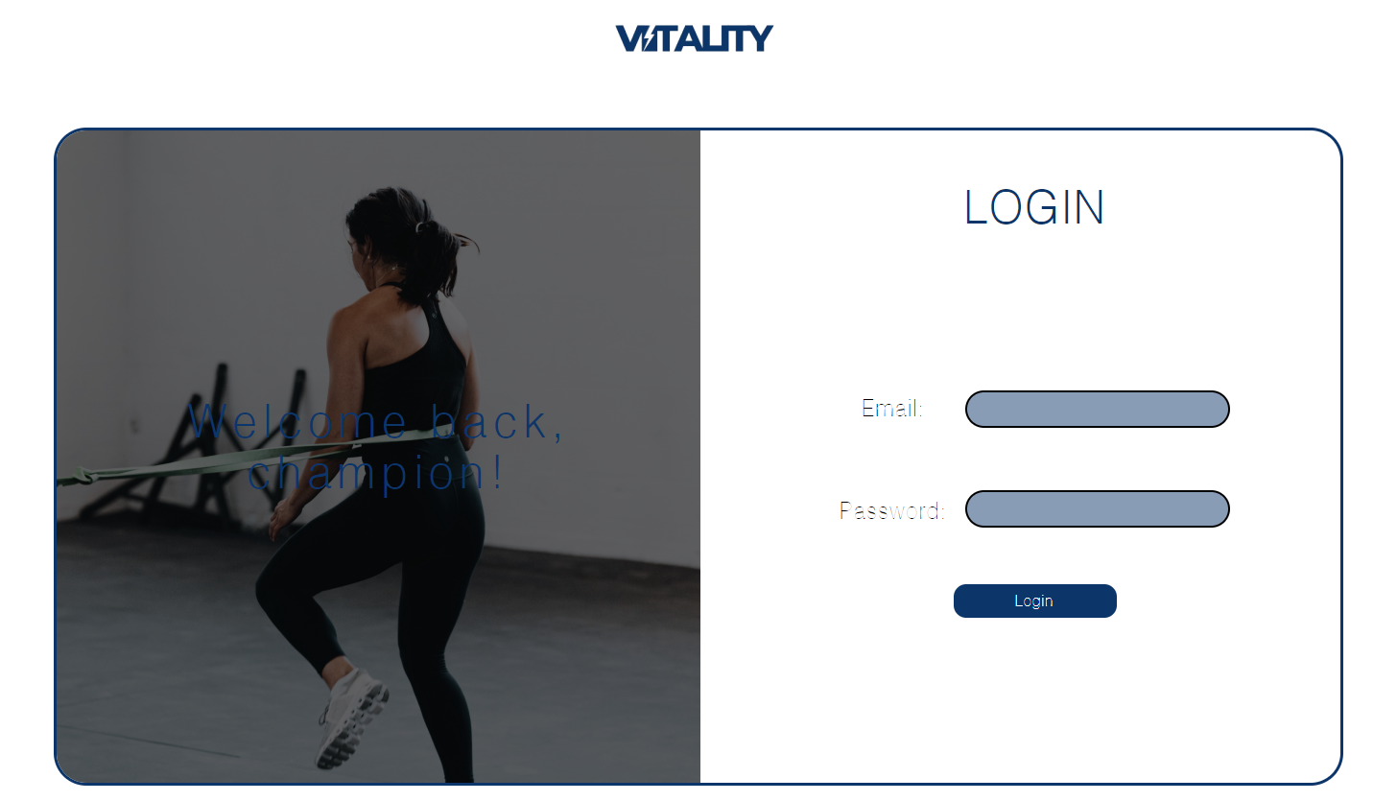

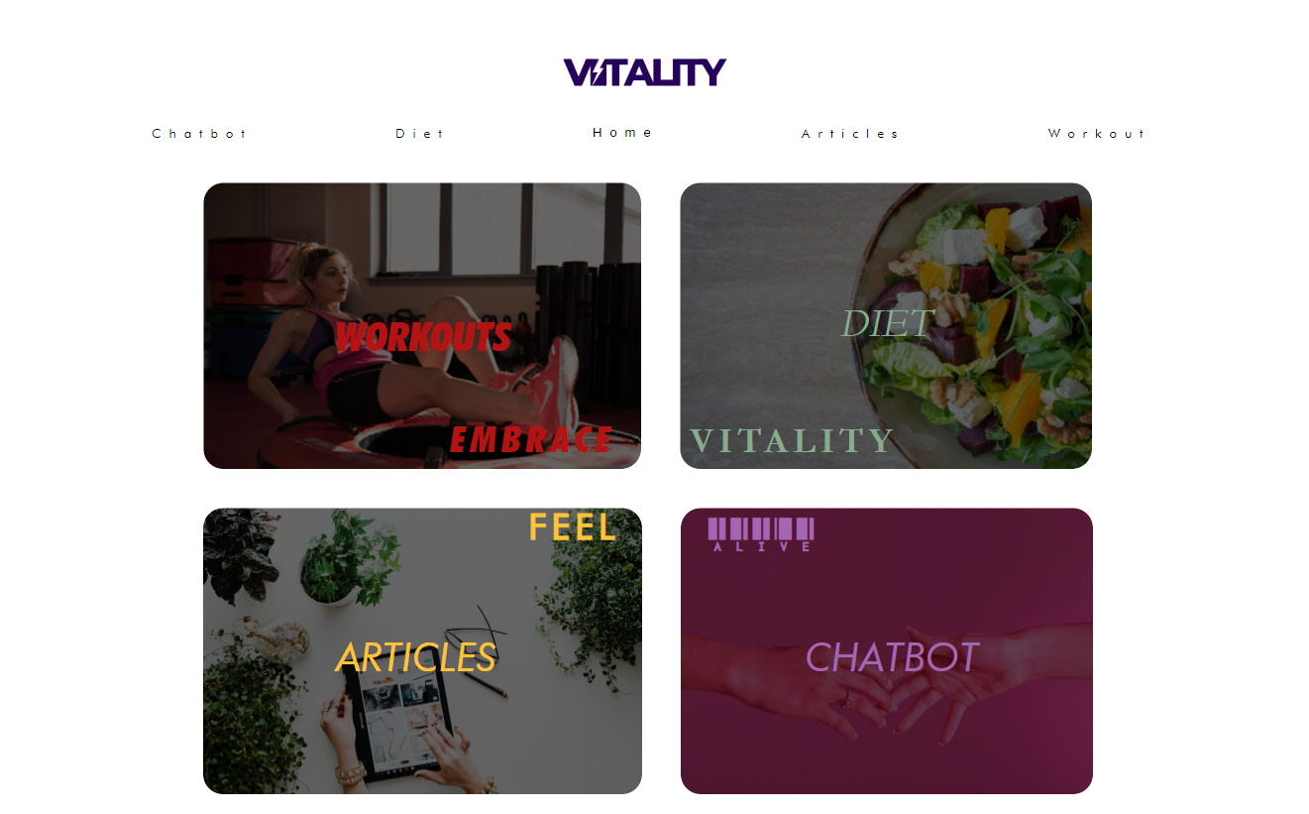

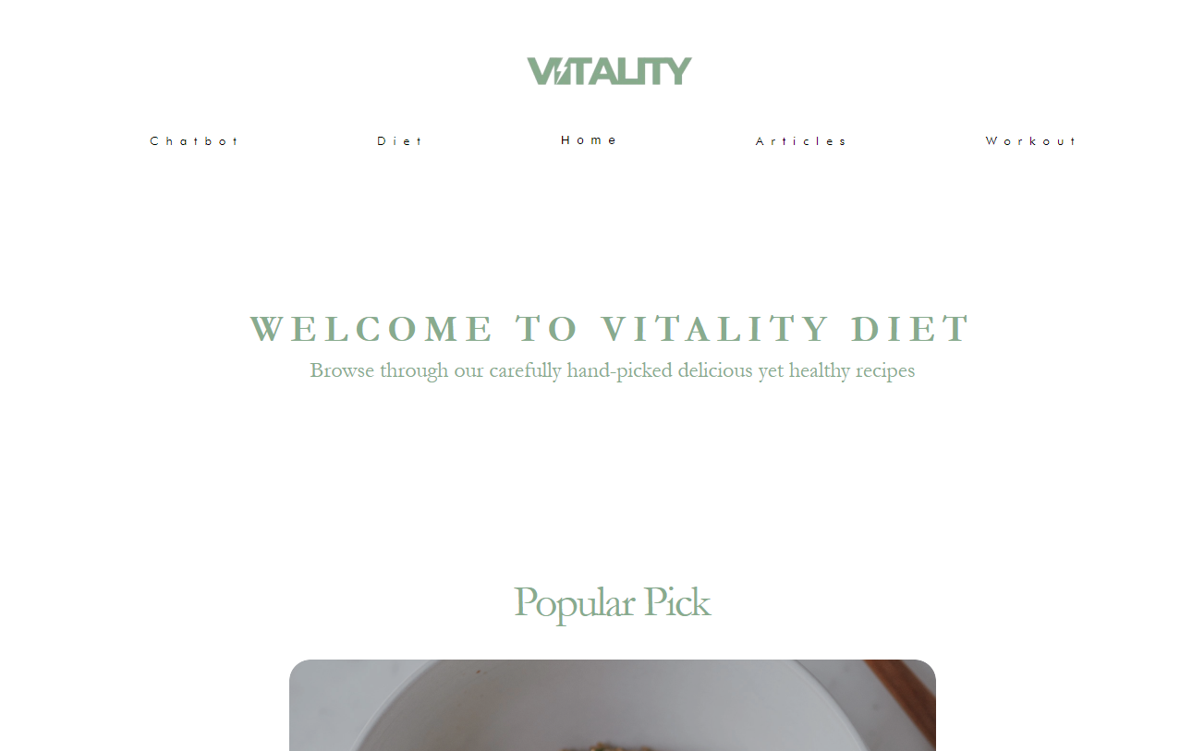

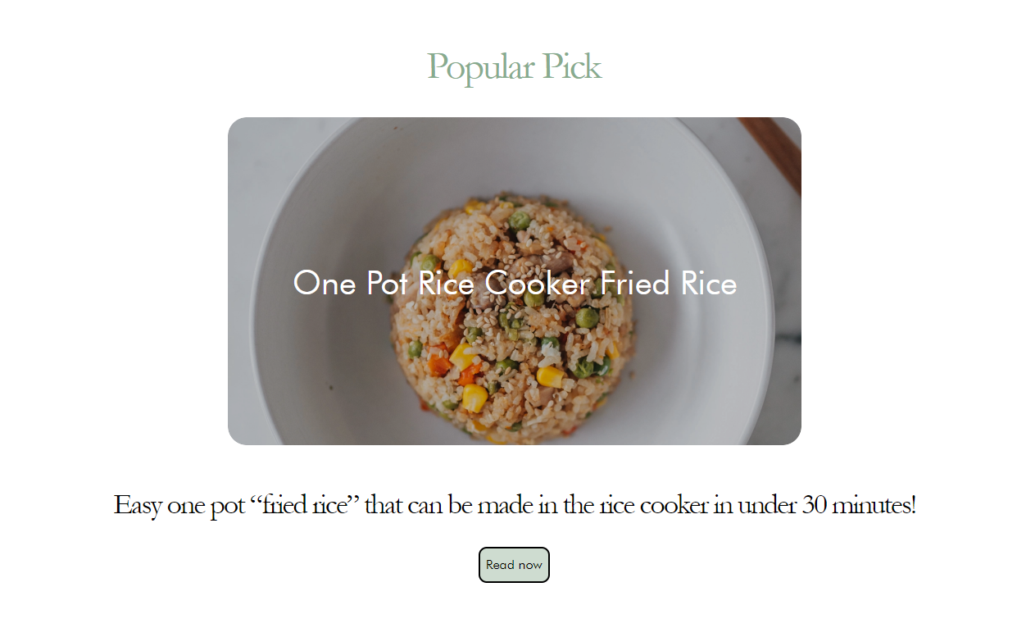

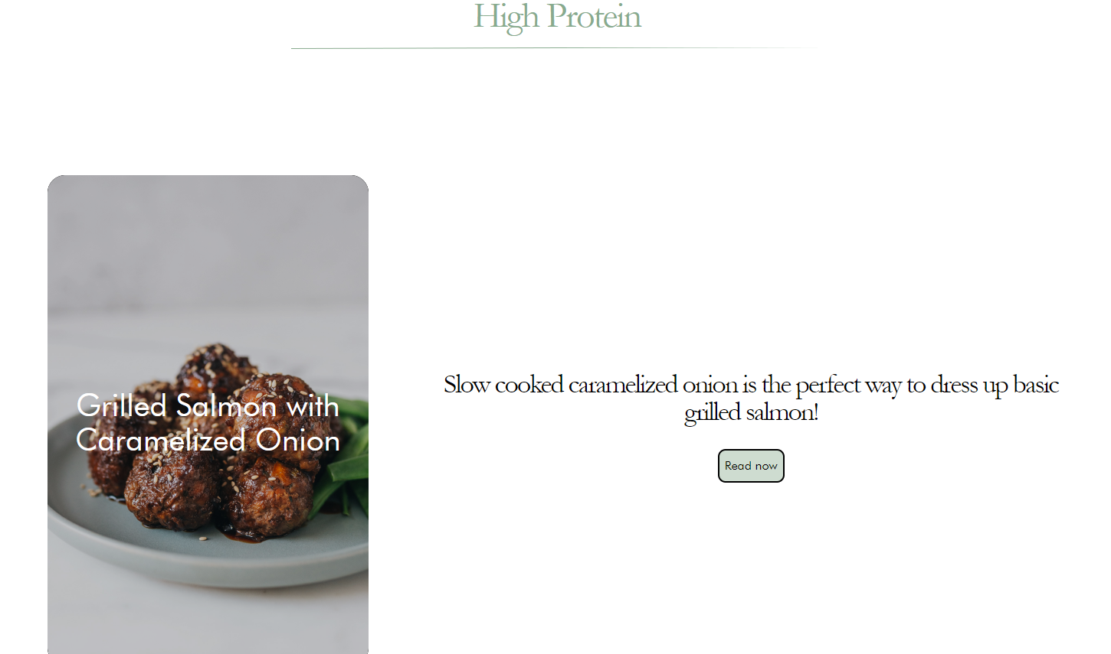

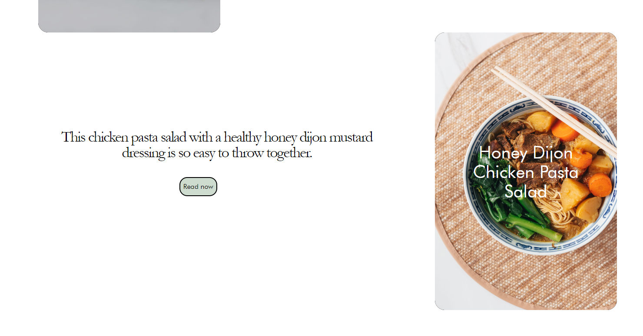

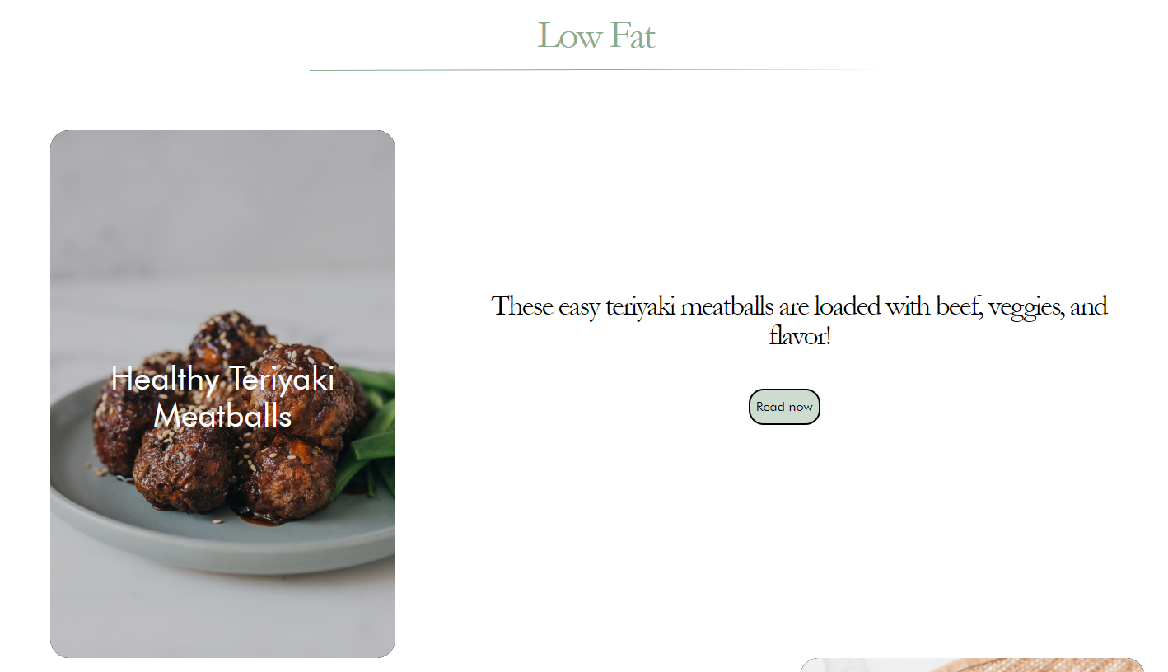

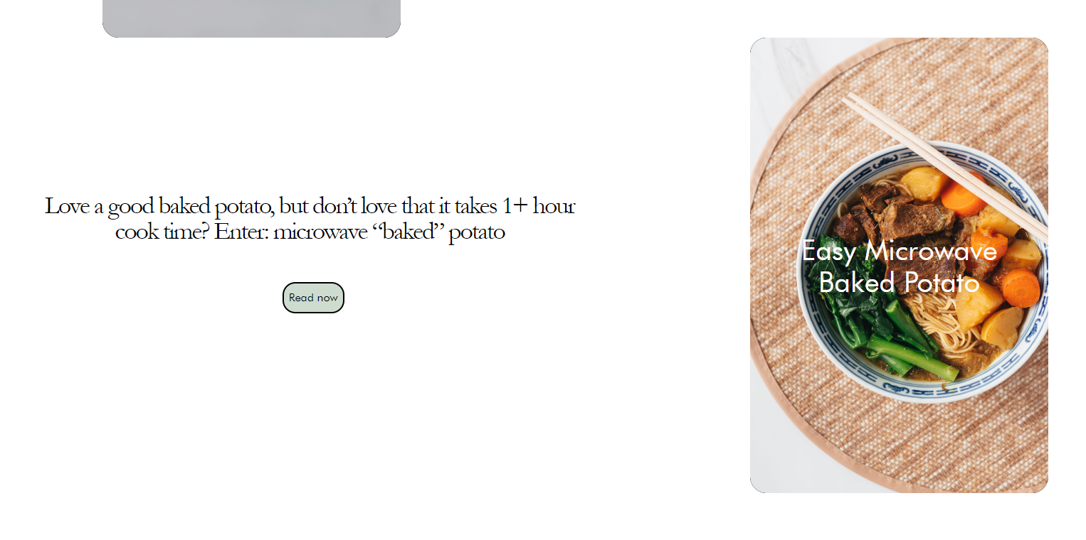

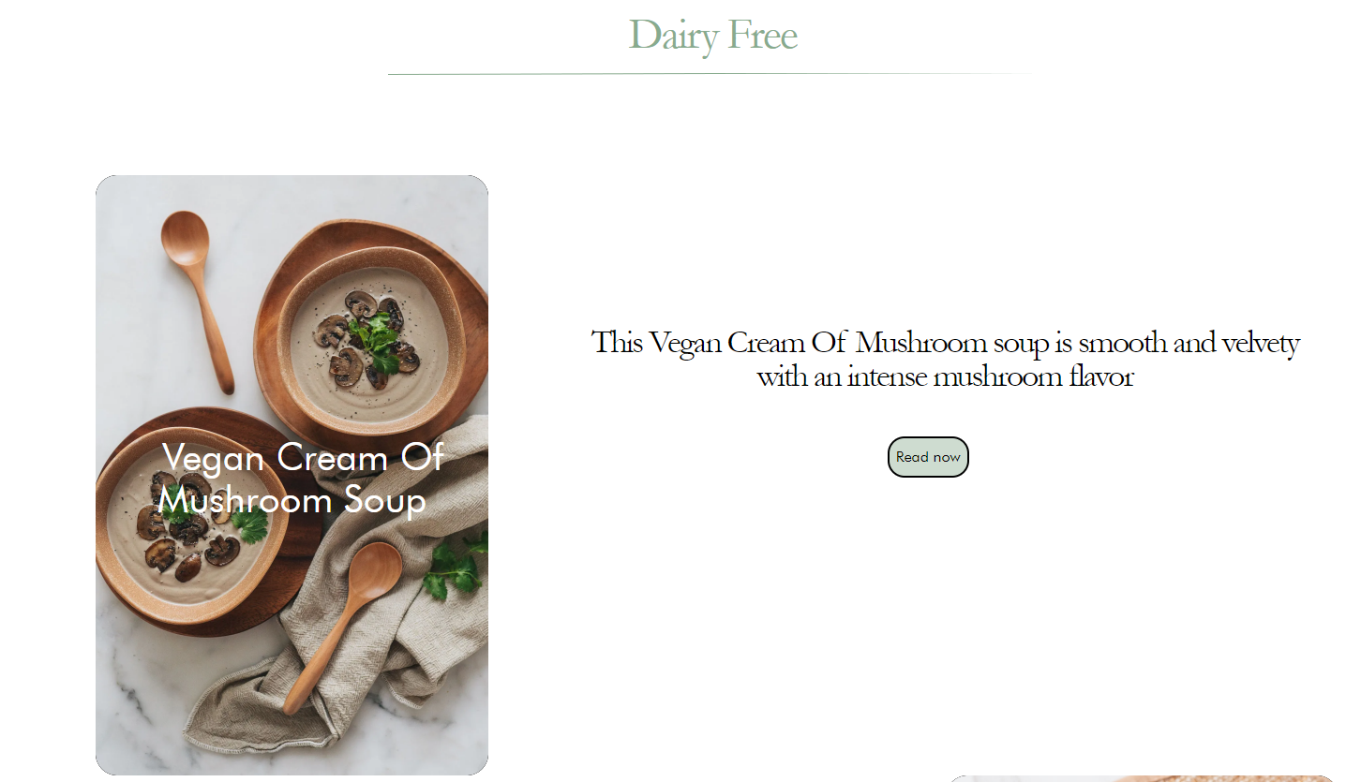

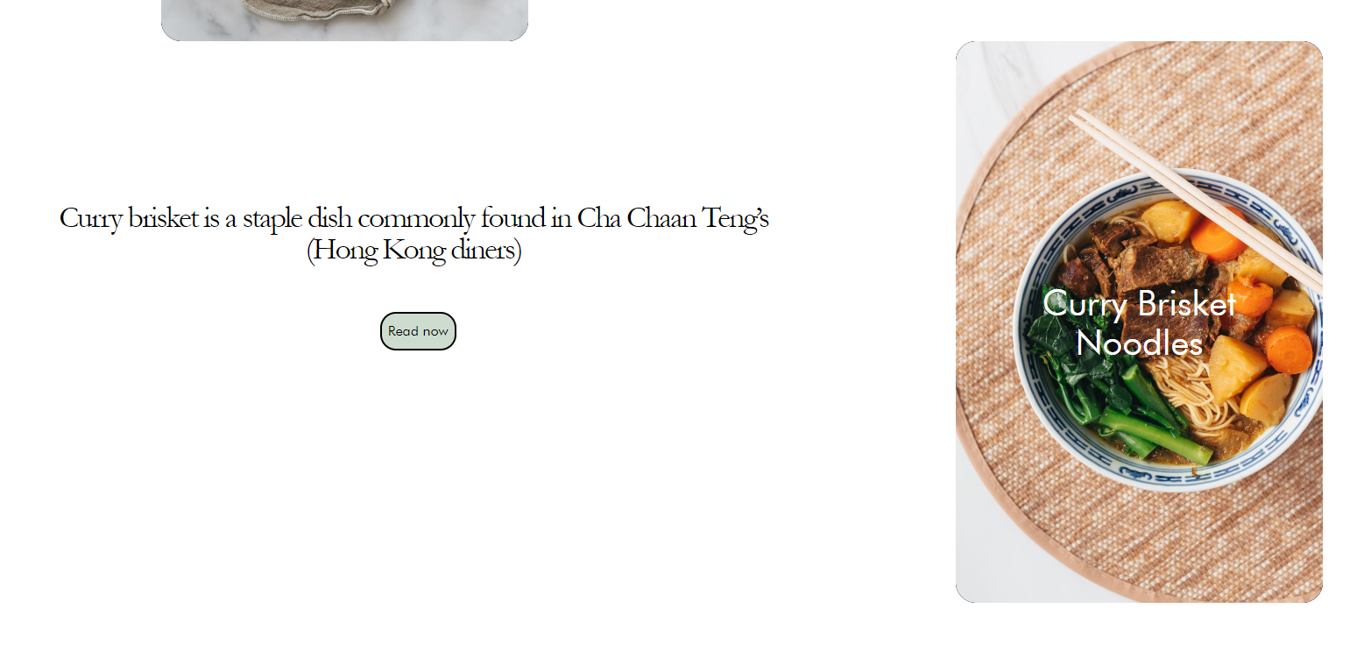

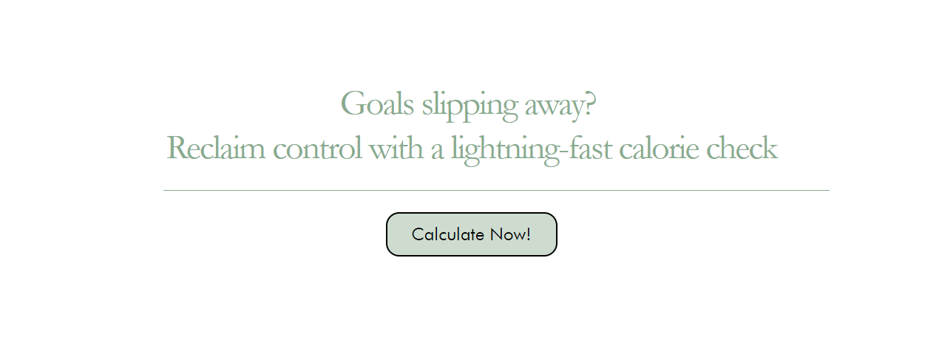

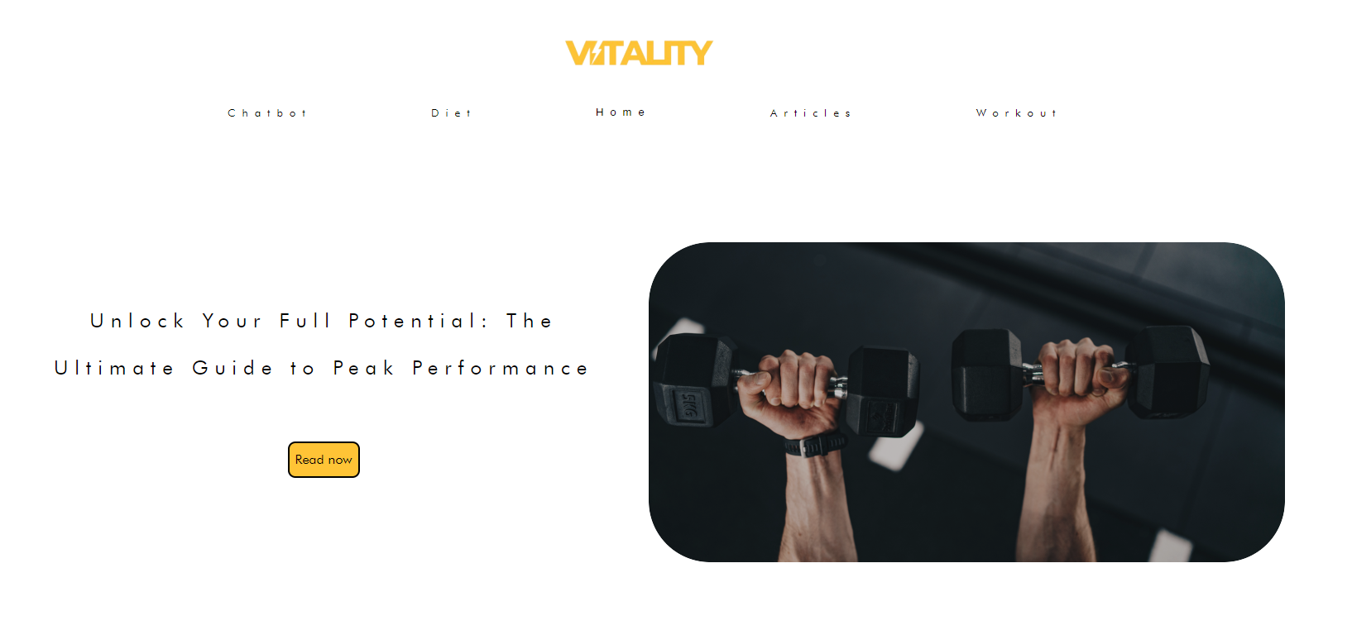

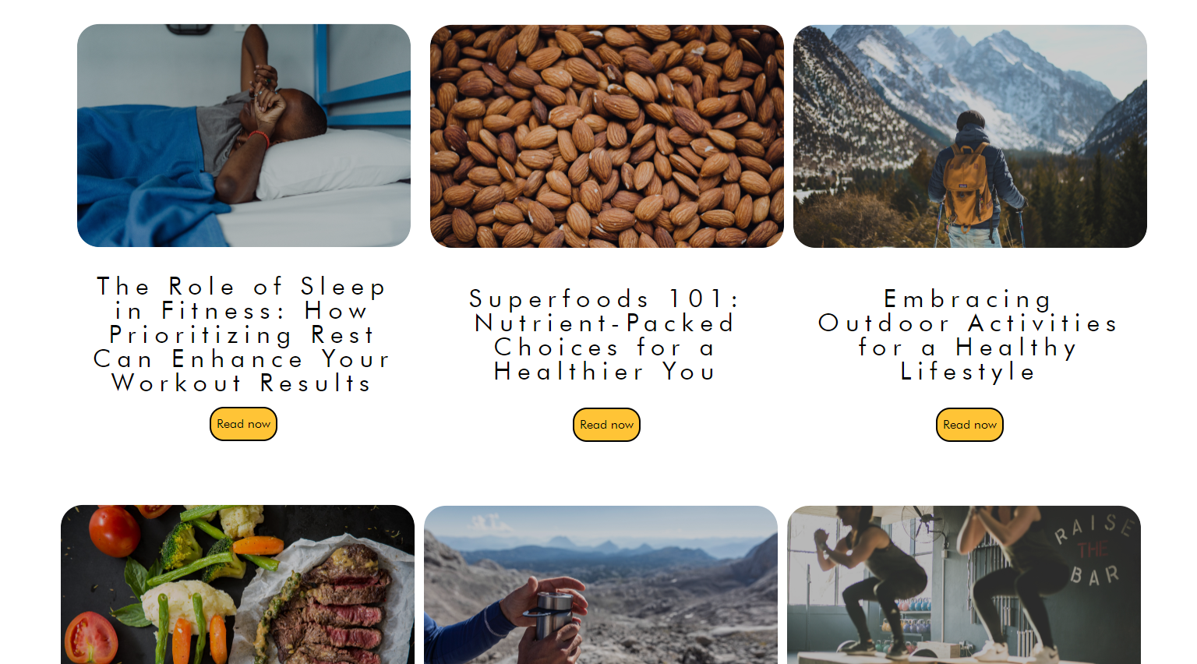

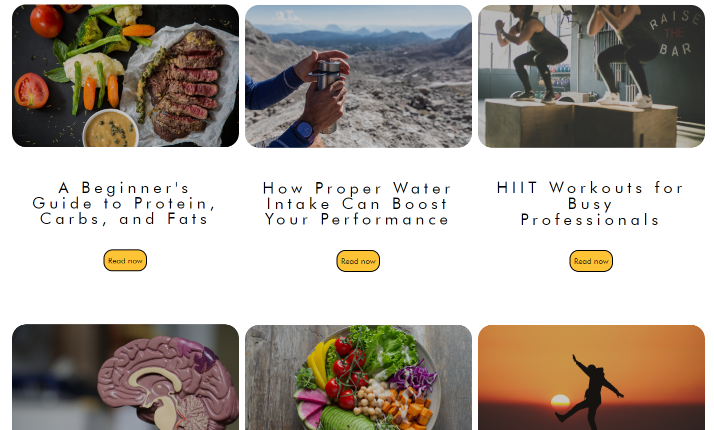

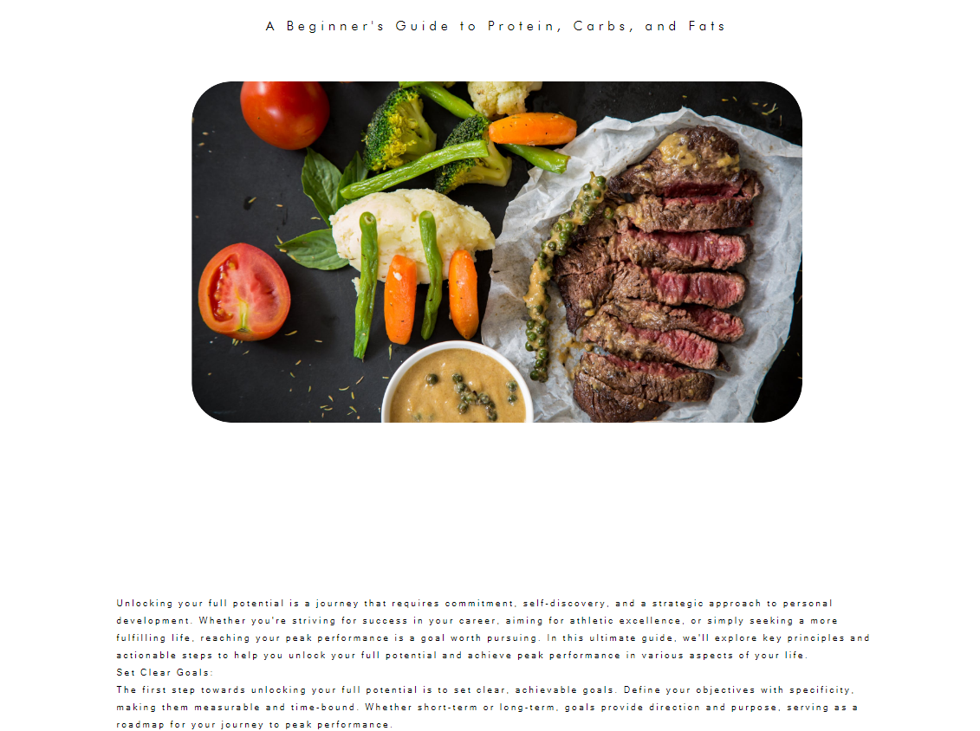

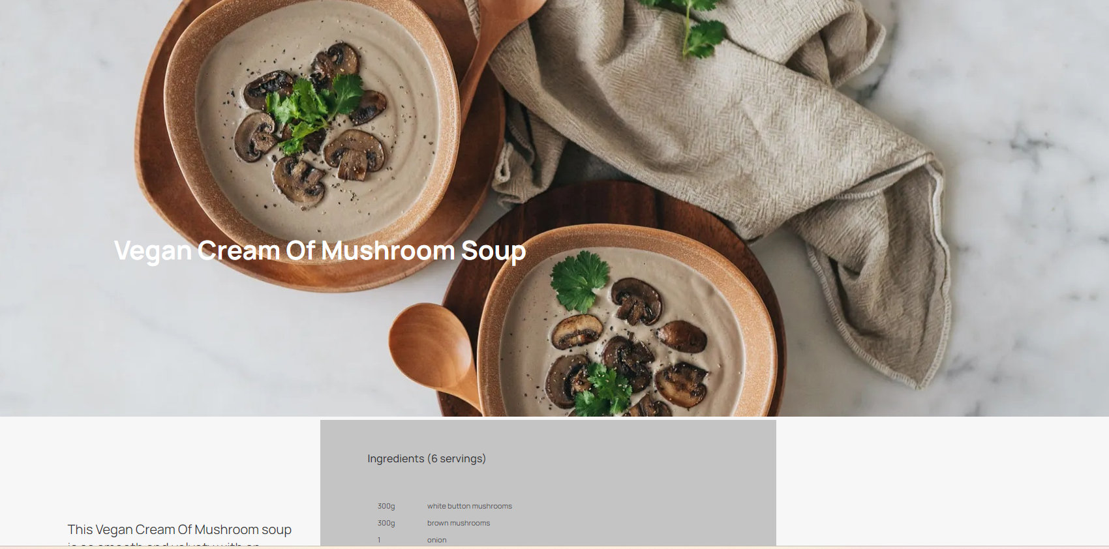

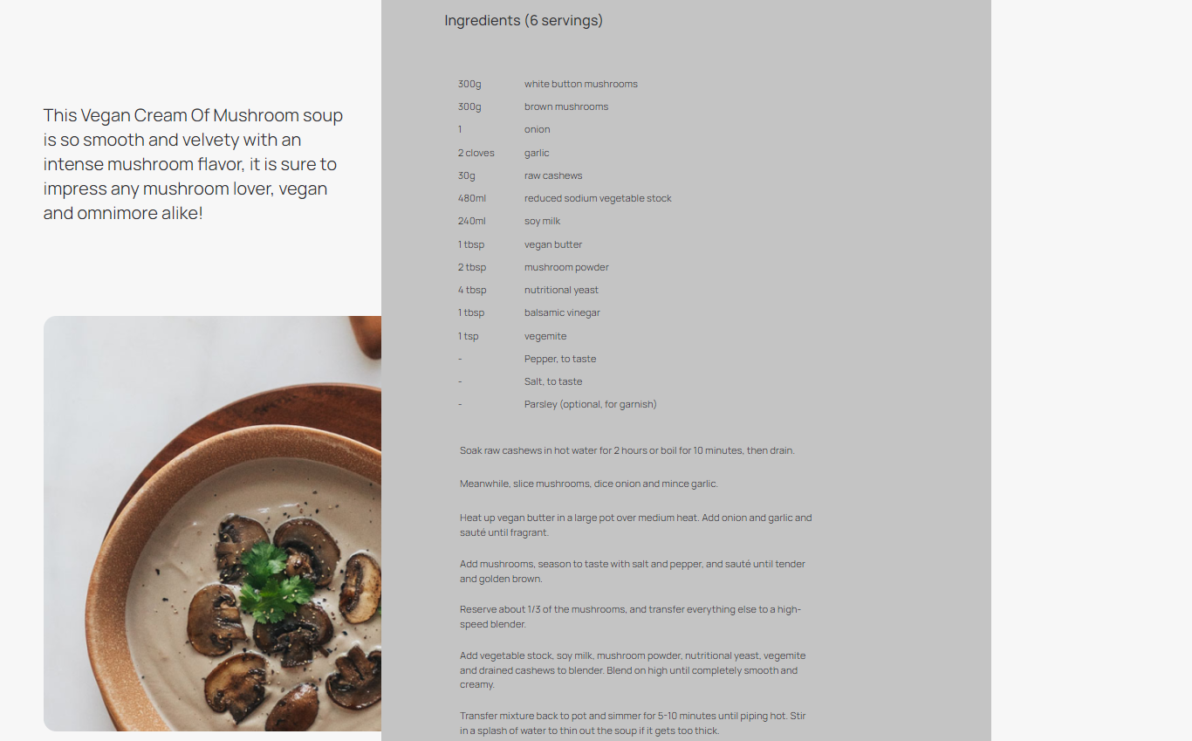

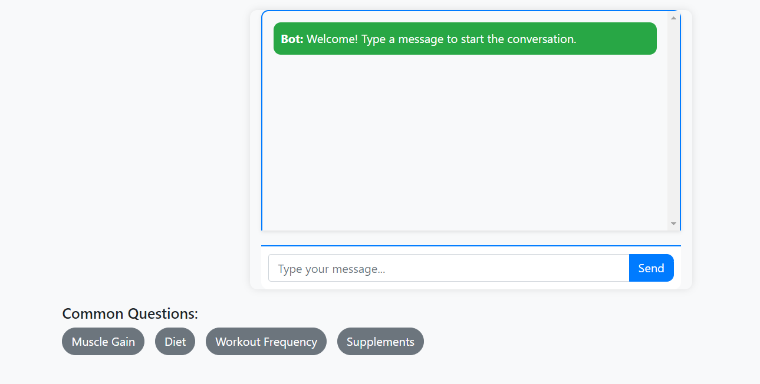

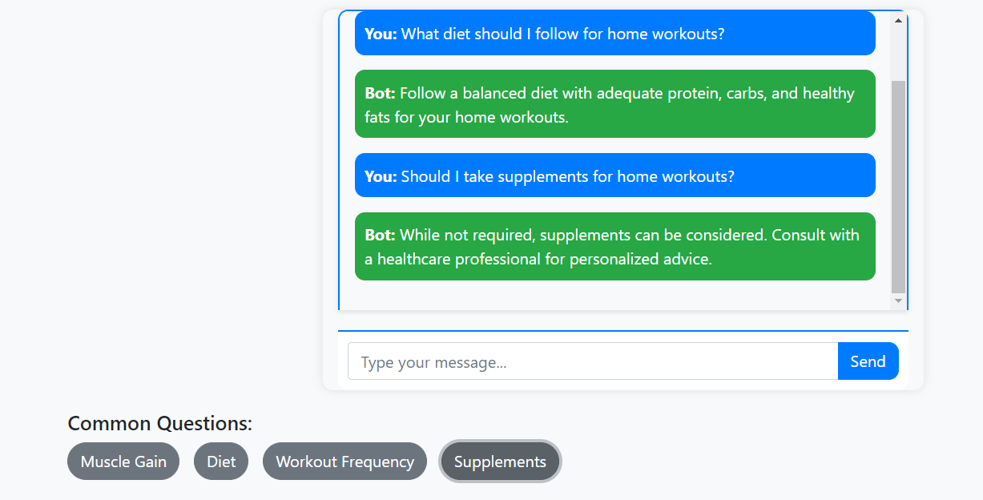

1. FIGMA SCREENSHOTS:

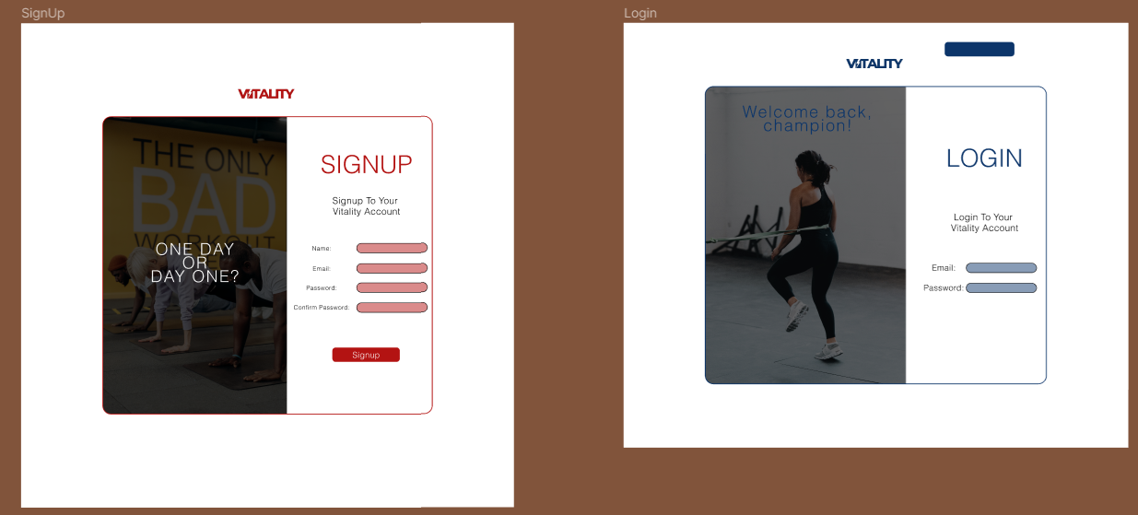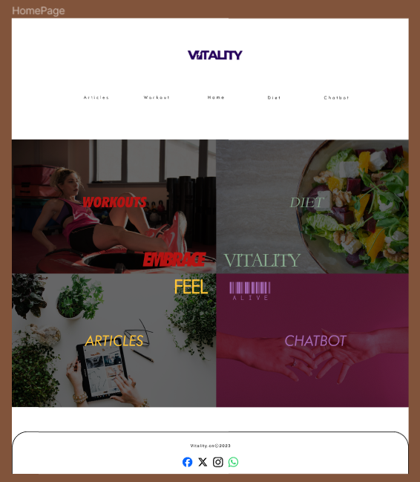

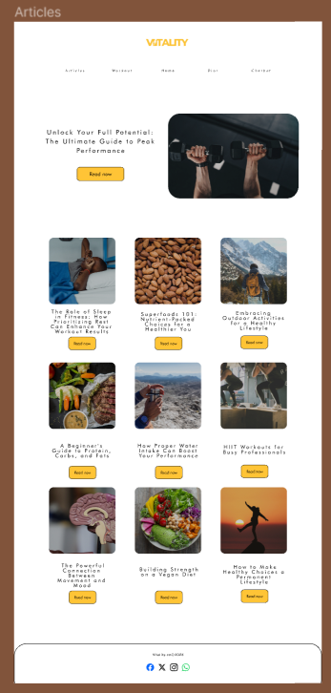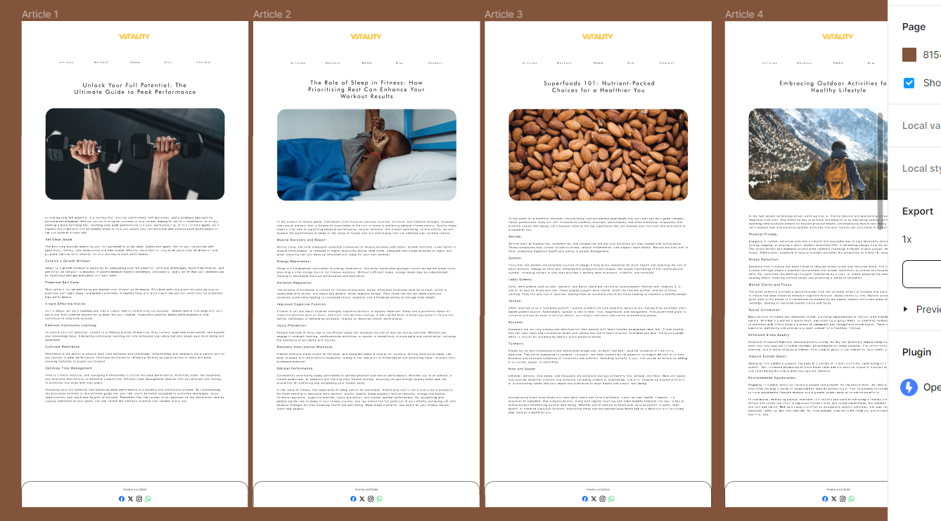

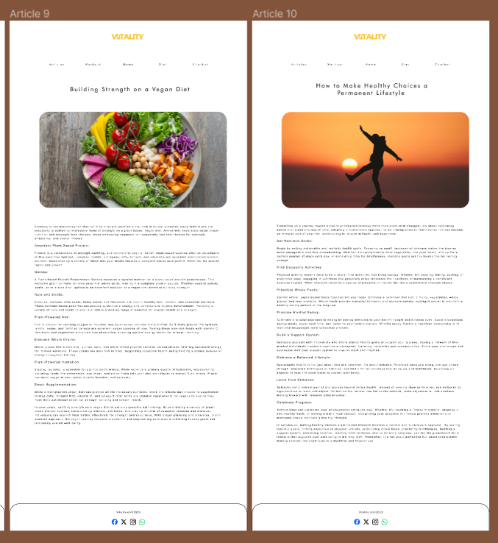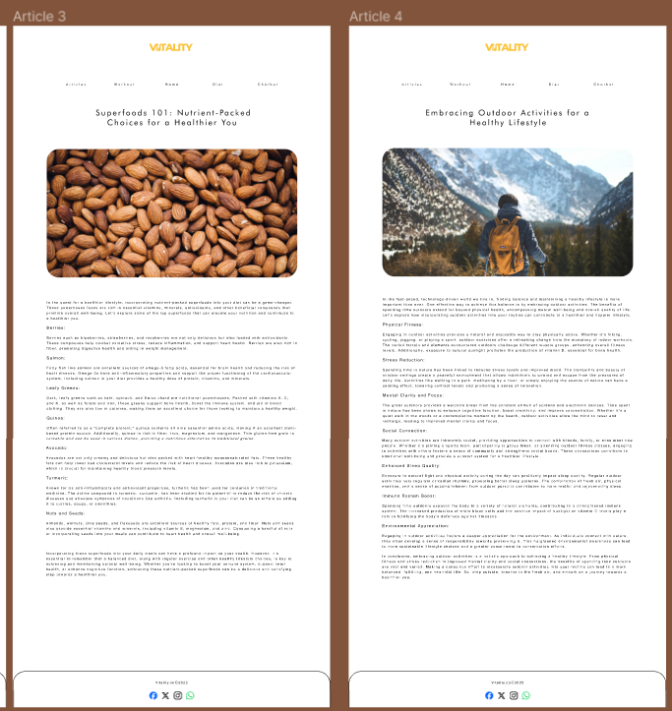

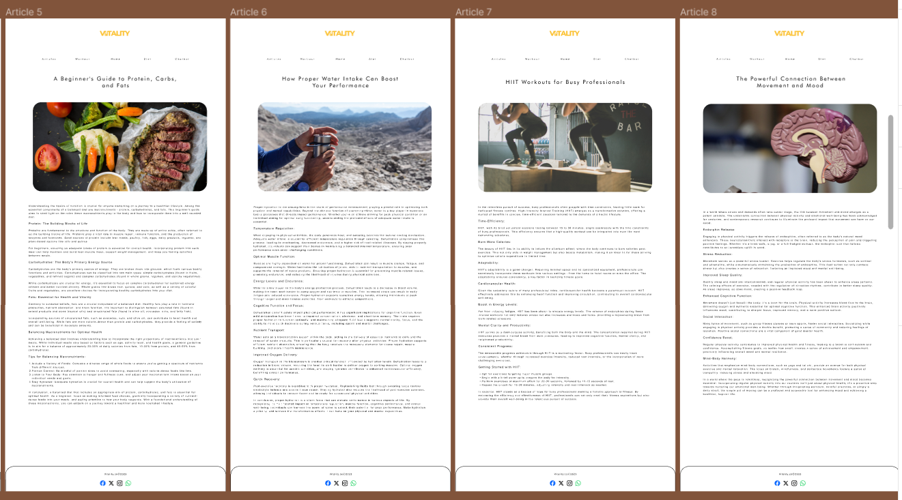

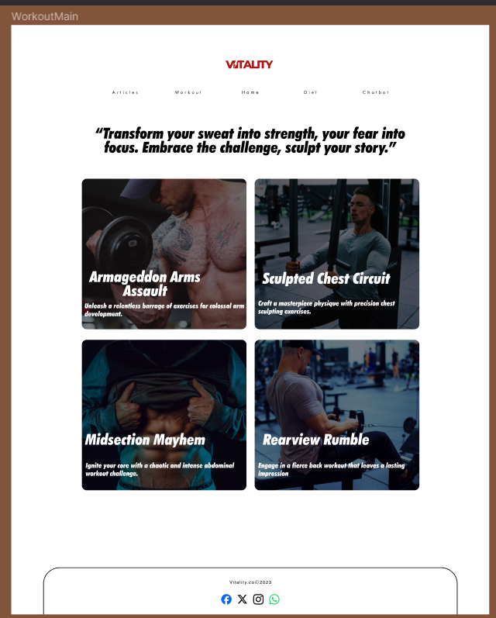

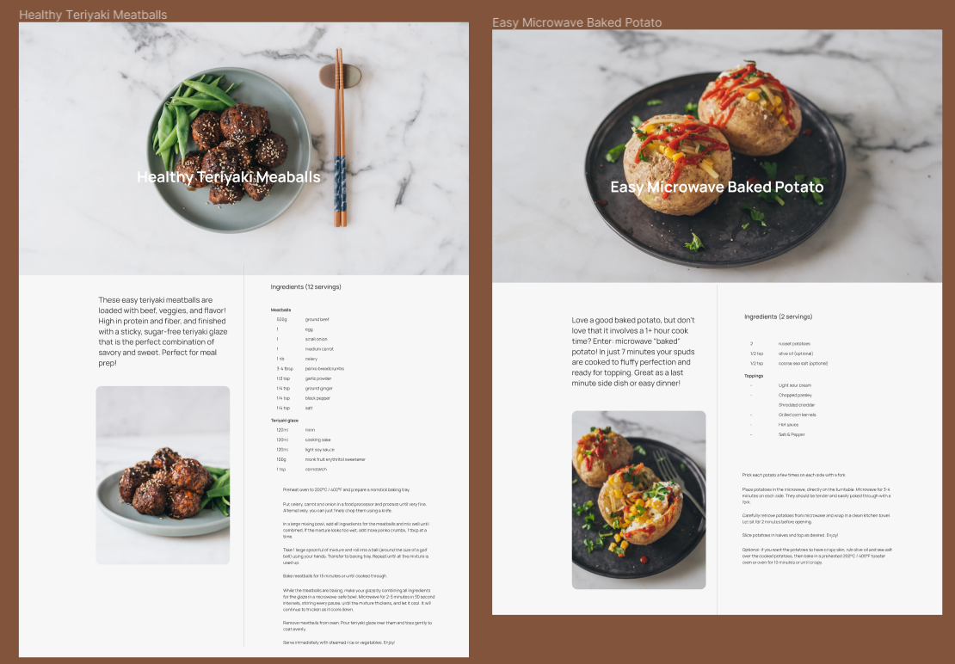

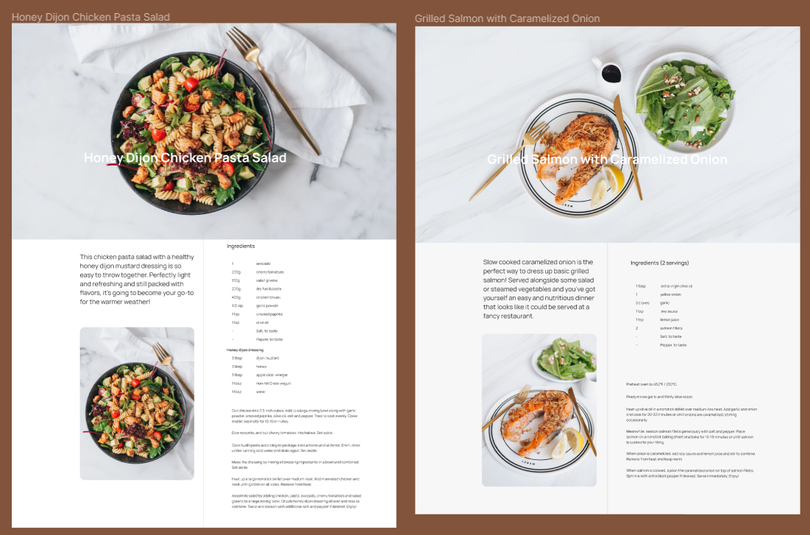

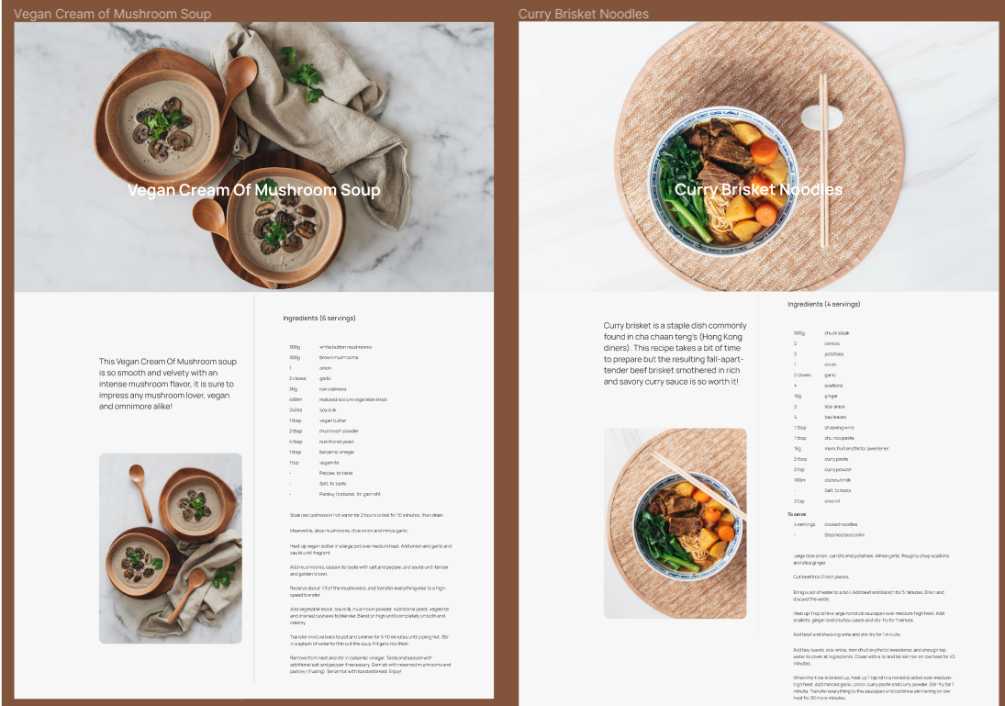

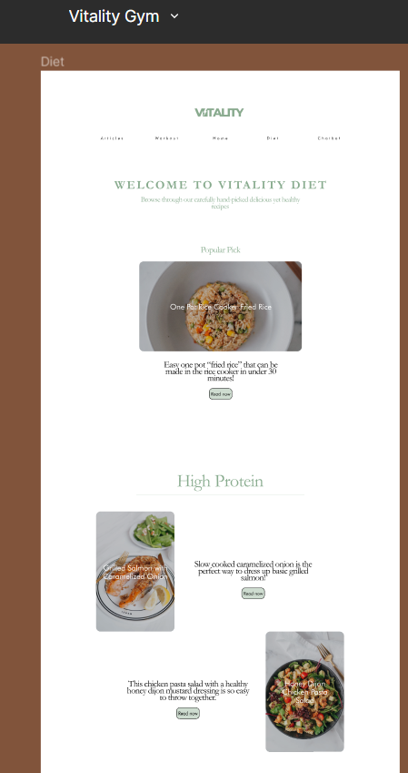

1. GITHUB SCREENSHOTS:

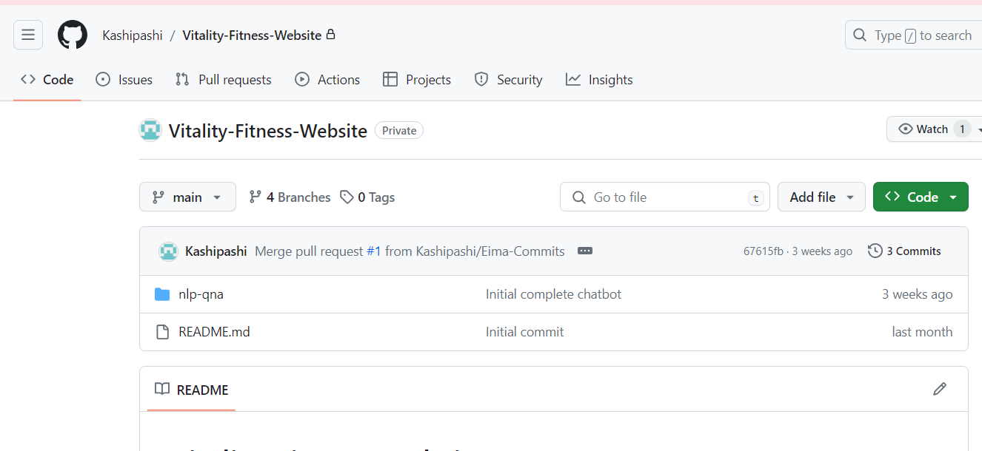

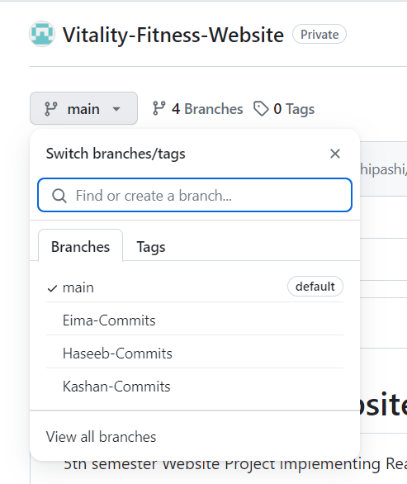

1. CONCLUSION

The Vitality Fitness Website is an innovative, personalized, and holistic wellness showcase in the ever-changing fitness industry. This tool effectively tackles the difficulties encountered by exercise enthusiasts, offering users of all skill levels a guided and user-friendly experience. An advanced application that surpasses traditional fitness platforms has been created through the combination of Node.js, React, MongoDB, and NLP technologies.

The Vitality Fitness Website provides tailored exercise regimens, dietary advice, and progress monitoring to enable users to start their fitness journeys with confidence and clarity. An AI chatbot and reward system combined improve user engagement by fostering an engaging and interactive environment. Users can learn more about the most recent trends and insights in the fitness industry with the help of the carefully chosen health articles written by certified experts.

As we come to the end of this project, it is clear that the Vitality Fitness Website redefines the user experience by going beyond the conventional bounds of fitness platforms. The dedication to fusing technology and customization has produced a complete digital wellness companion that not only offers the resources for physical transformation but also cultivates a feeling of knowledge, motivation, and community.

This project demonstrates how technology can be used to further the goal of well-being. The Vitality Fitness Website is more than simply a platform; it is a partner in each user's fitness journey, customizing its offerings to meet their specific needs and directing them in the direction of a happier, healthier way of living. We expect a positive influence on users' lives as they interact with this cutting-edge platform, turning their fitness goals into attainable and long-lasting successes. The Vitality Fitness Website is ready to be a reliable companion on this path to wellness as the quest for vitality continues.